The quest for physically realistic streamflow forecasting models
Clark MP¹, Kavetski D², Fenicia F³ and McMillan H⁴
¹National Center for Atmospheric Research, PO Box 3000, Boulder, CO, 80307, USA, mclark@ucar.edu. ²Environmental Engineering, University of Newcastle, University Drive, Callaghan, NSW 2308, Australia. ³Department of Environment and Agro-Biotechnologies, Centre de Recherche Public – Gabriel Lippmann, L-4422 Belvaux, Grand-Duchy of Luxembourg. ⁴National Institute for Water and Atmospheric Research, 10 Kyle Street, Christchurch, New Zealand.
Abstract: The current generation of hydrological models, including those used by operational agencies, are process-weak, and their calibration often results in unrealistic model parameters that (imperfectly) compensate for poor representation of key hydrological dynamics. Improving operational practice requires the operational forecasting community to have similar research priorities to the science community, that is, to develop more physically realistic hydrological models. This paper describes a methodology designed to facilitate the development and refinement of physically realistic streamflow forecasting models. We argue that the ongoing quest for more reliable hydrological models needs to be embedded in a hypothesis-testing framework that rigorously scrutinizes the model hypotheses against observed data. It is our proposition that this is best achieved using flexible modelling approaches, where different process representations and overall system hypotheses can be evaluated in a controlled and relatively independent way. We are optimistic that, when applied within a stringent hypothesis-testing framework that creatively uses available data from both experimental watersheds and operational observing networks, flexible modelling approaches can considerably advance the state of operational hydrological modelling and forecasting.
Keywords: Flexible model frameworks; operational forecasting.
- INTRODUCTION
Seasonal streamflow forecasts are typically produced using two classes of models: (1) statistical models; and (2) time stepping hydrological simulation models. The statistical approach uses regression-type models (e.g., Garen et al., 1992; Pagano et al., 2004). The predictor variables include those that provide information on the current hydrological state of the basin (e.g., antecedent precipitation over the past six months) as well as variables that describe meteorological conditions expected over the forecast period (e.g., El Niño Southern Oscillation (ENSO) indices). In the case of time stepping hydrological simulation models, the hydrological model is first run using historical data to estimate basin conditions at the start of the forecast period (e.g., snow and soil moisture), and then run over the forecast period using an ensemble of weather sequences conditioned on numerical weather prediction forecasts and seasonal climate outlooks (e.g., Day, 1985; Clark and Hay, 2004; Wood and Lettenmaier, 2006).
Both classes of methods have serious limitations.
- The statistical forecasts assume stationarity in vegetation and climate. This assumption may not be justified, as the impacts of climate change are already apparent in many parts of the globe, and vegetation changes associated with land development, insect infestation, and forest fire are pronounced in many regions. For example, in the western USA, climate change impacts are manifested in more precipitation falling as rain rather than snow and earlier timing of snowmelt runoff. This stationarity assumption severely compromises the reliability of these statistical forecasts.
- The hydrological models used by many agencies are process-weak. For example, the models used by the River Forecast Centers in the USA do not explicitly simulate key processes, such as interception/sublimation of snow from the forest canopy. In order to provide acceptable simulations over the calibration period, model parameters are forced to take unrealistic values to compensate for structural weaknesses. Once the model structure and parameters lose the connection to the hydrological mechanisms they are intended to represent, the calibrated models become reliant on stationarity in vegetation and climate.
We contend that time stepping hydrological models have a significant potential to produce reliable streamflow forecasts. However, the physical processes represented in these models must be substantially improved in order to mitigate against the non-stationarity predicament that plagues the current generation of operational streamflow forecasting systems.
This paper describes a methodology designed to facilitate the development and refinement of physically realistic streamflow forecasting models. Section 2 makes the case for using flexible modelling frameworks for developing physically realistic hydrological models, and Section 3 provides a case study describing an application of the flexible modelling methodology using data from an experimental catchment. The paper concludes with an assessment of the current status and future challenges of flexible modelling methodologies.
- FACILITATING THE QUEST FOR PHYSICALLY REALISTIC HYDROLOGIC MODELS
Developing physically realistic hydrological models requires three main steps: (1) identify the key environmental processes and drivers of interest, (2) construct alternative ways of representing these processes within a hydrological model; and (3) evaluate the alternative model hypotheses against available data. We argue that the ability of flexible modelling frameworks to address steps (1) and (2), in combination with incisive diagnostics to scrutinize both individual process representations and the overall model architecture against observed data in step (3), provides a powerful and systematic approach for model improvement, in both the scientific and operational research spaces.
  - Flexible modelling frameworks as hypothesis-testing tools
Model development in catchment-scale hydrology requires both isolating and linking a myriad of decisions (i.e., hypotheses) of different types and at different levels of conceptualization (Clark et al., 2011). Typically, a model developer will begin by delineating the system of interest, including its initial and boundary conditions, forcing and response variables. Judgements must then be made regarding the processes and state variables to be included in the model. For example, should interception be represented? Should distinctions be made between deep and shallow subsurface flows? A prudent model developer will then consider alternative representations of a particular process (e.g., different representations of baseflow processes). In many models, decisions are needed regarding the appropriate model architecture, which ties together the individual elements of a model. Model architecture may include process separation (e.g., baseflow versus interflow in a “fully lumped” model), spatial discretization into grid cells, sub-basins, land cover types (in a spatially distributed model), etc.
When approached from this “hypothesis development and testing" perspective, hydrological models must be treated as a set of interlinked testable components (constituent hypotheses). To be scientifically rigorous, the decomposition of a (hydrological) model into its constituent hypotheses must be carried out in a systematic manner. This requires explicitly identifying the usually interrelated individual decisions regarding system and process conceptualization, selection and representation made during model development.
Flexible model frameworks will be most successful if they include the following attributes:
- Capability to isolate different decisions regarding process selection and representation, e.g., based on established theory, experimental insights, or on other prior perceptions.
- Separation of the model equations from their solutions, especially if the latter require numerical approximations [e.g., Clark and Kavetski, 2010; Kavetski and Clark, 2010; 2011].
- Capability to modify model components within modular framework and software, where multiple options can be selected for each modelling decision. The modular approach must account for frequent interdependencies between different modelling decisions.
Important progress has already been made using such flexible model frameworks in catchment-scale hydrology. For example, the Framework for Understanding Structural Errors (FUSE) facilitates the investigation of fundamental model-building decisions, including (i) the choice of state variables in the unsaturated and saturated zones; and (ii) the choice of flux equations describing surface runoff, baseflow, evapotranspiration, etc. [Clark et al., 2008]. Similarly, the SUPERFLEX model allows varying the number of stores, their connectivity and internal constitutive relations to explore and compare alternative conceptualizations of catchment-scale dynamics, using different types of experimental data [Fenicia et al., 2008; Fenicia et al., 2011]. Other flexible model frameworks are available in hydrology [e.g., Desborough, 1999; Smith and Marshall, 2010; Niu et al., 2011] and in other environmental sciences (e.g., the multi-physics package for atmospheric modelling described by Jankov et al. [2005]).
  - Testing model hypotheses
The need for a more rigorous scrutiny of hydrological models is widely recognized. For example, Kuczera and Franks [2002] stress that a major challenge is to expose internal variables to scrutiny, since this more directly challenges the internal model dynamics against observed data.
Two main categories of model diagnostics (hypothesis-testing tools) can be employed:
- Improved use of traditional data, in a way that focuses on reproducing hydrological behaviour rather than merely matching data with model simulations. This avoids reliance on mere curve fitting and would make the model more robust under changes in climatology, land use conditions, etc. Even streamflow measurements alone can support a richer set of diagnostics: they can be separated into recession periods versus periods that are actively “driven” by rainfall [e.g., Boyle et al., 2000], used to generate a diagnostic signatures for different processes within a model [Gupta et al., 2008], etc.
- New types of data. In some cases, scrutinizing certain model hypotheses may require data for which measurement technologies are still unreliable, or not yet available. Yet, at least in experimental catchments, notable progress is already apparent in collecting and utilizing independent data on internal hydrological processes. These insights can often be transferred to more general modelling scenarios.
In either case, data uncertainty and the scale mismatch between measurements and model elements will necessarily constrain our ability to discriminate among competing hydrological hypotheses. Addressing this critical issue requires a careful analysis of the sampling and measurement errors of observational systems [e.g., Rodriguez-Iturbe and Meija, 1974; Villarini et al., 2008; McMillan et al., 2010], and reflecting this uncertainty in model inference, analysis and prediction [e.g., Kavetski et al., 2006; Renard et al., 2010, in press].
- CASE STUDy: HYDROLOGICAL PROCESSES IN AN EXPERIMENTAL CATCHMENT
This section illustrates an application of flexible model structures in the Mahurangi experimental catchment, in Northland, New Zealand [McMillan et al., 2011; Clark et al., 2011]. The data were collected as part of the Mahurangi River Variability Experiment (MARVEX; Woods et al., 2001), which investigated the space–time variability of the catchment’s water balance. MARVEX ran from 1997 to 2001, and included data from a network of 29 nested stream gauges and 13 rain gauges, as well as detailed measurements in different sub-areas of the basin. Intensive observations during MARVEX were made in the vicinity of the Satellite Station, concentrated in two headwater catchments of the Mahurangi: Satellite Left (57.3 ha) and Satellite Right (25.1 ha). These intensive observations included high-resolution spatial snapshots of soil moisture variability across the hillslope at depths of 6 cm and 30 cm, as well as high-resolution time series of soil moisture at six points within the two satellite catchments (Wilson et al., 2003; Western et al., 2004). The observations also included tracer experiments, soil sampling and analysis, and measurements of rainfall, water table depth, and flow in the smaller 1.61 ha ‘Kauri Tree Catchment’, nested within the Satellite Right catchment.
Multiple time series were analysed to provide insight into different model processes:
- Recession analysis, to identify appropriate model representations of baseflow;
- Analysis of the behaviour of soil moisture above field capacity, to identify the appropriate model representation of vertical drainage;
- The variability of soil moisture at different depths, to identify the water holding capacity of the soil and improve the estimation of evapotranspiration fluxes;
- Relationships between precipitation and flow for individual storms, to identify thresholds in the runoff response;
- Analysis of the temporal lag between precipitation and runoff, to identify the balance of near-surface and baseflow pathways.

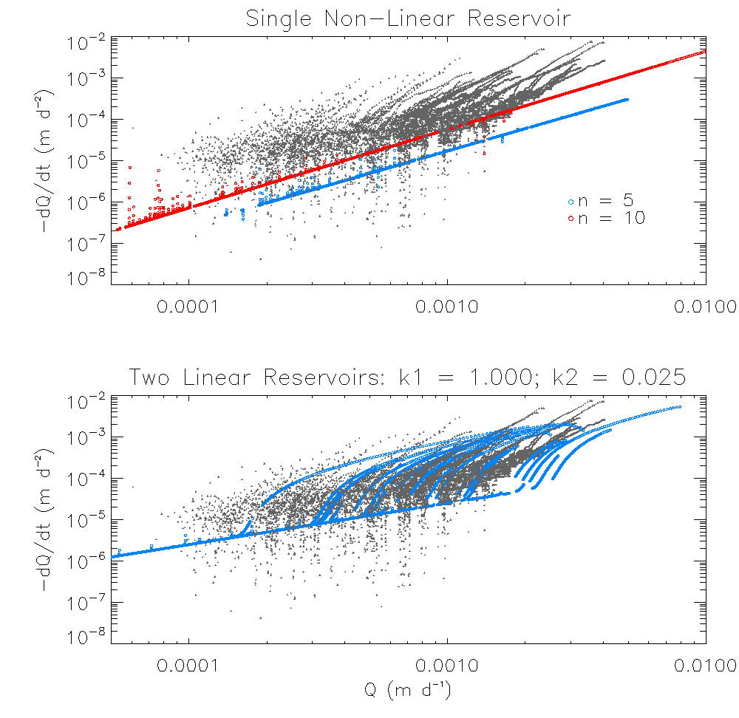
Model sensitivity studies included (among many other tests) evaluating different representations of recession behaviour. The recession analysis presented in Figure 1 illustrates that a single non-linear reservoir is unable to reproduce the highly nonlinear recessions, where the gradient of versus exceeds 2. Moreover, the single nonlinear reservoir is characterized by a unique storage-discharge relationship, and is unable to reproduce the seasonal differences between individual recessions that can be seen in the observed data. By contrast, a two linear reservoir model is able to reproduce the non-unique relationship between total storage and discharge, because different storages in the two individual reservoirs will produce different outflow (and hence different recessions) even if the total storage is the same. However, it does not reproduce the strongly nonlinear behaviour at the start and end of the recessions. It is more likely that the recession behavior represents a combination of horizontal heterogeneity and hydrologic complexity, i.e., multiple non-linear reservoirs with different transmissivity, (as argued by Harman et al, 2009).
Figure 1. Recession behaviour when using a single non-linear reservoir (top) and two linear reservoirs (bottom), compared to the observed recession behaviour (grey symbols, repeated in both plots). The top plot illustrates simulations using different baseflow exponents. Figure reproduced from Clark et al., [2011] with permission from Wiley-Blackwell.
This case study presents only a single example of isolating and testing model hypotheses. Since in most cases, our process-based evaluations of different model structures has highlighted the need for a more detailed representation of catchment dynamics [Clark et al., 2011; Kavetski and Fenicia, 2011], improving the reliability of hydrological predictions may therefore require a shift from exceedingly simplistic ‘bucket-style’ models to process-based models that better resolve internal catchment dynamics [e.g. Ivanov et al., 2004]. Data support for this increase in complexity may come from the inclusion of multiple response time series (including observations of internal model states, whenever available), additional model performance diagnostics, advances in process understanding in experimental basins, etc.
- SUMMARY AND DISCUSSION
We argue that the current generation of time stepping hydrological models used by operational forecasting agencies are process-weak, making them non-robust with respect to the same stationarity predicament that plague statistical streamflow forecasting systems. The operational forecasting community therefore has similar research priorities to the science community, that is, to develop physically realistic hydrological models.
The development of physically realistic models requires more rigorous scrutiny of the model hypotheses against observed data. It is our proposition that such hypothesis-testing is best pursued using flexible modelling approaches, where different process representations and overall system hypotheses can be evaluated in a controlled and relatively independent way. Ongoing investigations indicate that, when applied with adequate scrutiny of internal process representation, flexible modelling approaches can lead to fundamentally more scientifically defensible and operationally reliable hydrological models. This is of particular importance if hydrological predictions and forecasting are needed under conditions of environmental variability, including those associated with climatic and land use change.
Acknowledgements. This paper benefited from constructive comments from two external reviewers. We thank Wiley-Blackwell for allowing us to reproduce Figure 1.

REFERENCES
Clark, M. P., and L. E. Hay, 2004: Use of medium range numerical weather prediction model output to produce forecasts of streamflow. J. Hydrometeor., 5, 15–32.
Clark, M. P., A. G. Slater, D. E. Rupp, R. A. Woods, J. A. Vrugt, H. V. Gupta, T. Wagener, and L. Hay (2008), Framework for Understanding Structural Errors (FUSE): A modular framework to diagnose differences between hydrologic models, Water Resour Res, 44, W00B02.
Clark, M.P., and D. Kavetski, 2010: The ancient numerical daemons of conceptual hydrological models. Part 1: Fidelity and efficiency of time stepping schemes. Water Resources Research, 46, W10510, doi:10.1029/2009WR008894.
Clark, M. P., H. K. McMillan, D. B. G. Collins, D. Kavetski, and R. A. Woods, 2011: Hydrological field data from a modeller’s perspective. Part 2: Process-based evaluation of model hypotheses, Hydrological Processes, 25, 523-543, doi: 10.1001/hyp.7902.
Clark, M. P., Kavetski, D. and F. Fenicia (2011) Pursuing the method of multiple working hypotheses for hydrological modelling, Water Resources Research, 47, W09301.
Day, G. N., 1985: Extended streamflow forecasting using NWSRFS. J. Water Resour. Plann. Manage., 111, 157–170.
Desborough, C. E. (1999), Surface energy balance complexity in GCM land surface models, Climate Dynamics, 15, 389-403.
Fenicia, F., H. H. G. Savenije, P. Matgen, and L. Pfister (2008b), Understanding catchment behavior through stepwise model concept improvement, Water Resour Res, 44, W01402.
Fenicia, F., Kavetski, D and H. H. G. Savenije (2011) Elements of a flexible framework for conceptual hydrological modeling. Part 1. Motivation and theoretical development, Water Resources Research, 47, W11510, doi:10.1029/2010WR010174.
Garen, D. C., 1992: Improved techniques in regression-based streamflow volume forecasting. J. Water Resour. Plan. Manage., 118, 654–670.
Gupta, H. V., T. Wagener, and Y. Liu (2008), Reconciling theory with observations: Elements of a diagnostic approach to model evaluation, Hydrological Processes, 22, 3802-3813.
Harman CJ, Sivapalan M, Kumar P. 2009a. Power law catchment-scale recessions arising from heterogeneous linear small-scale dynamics. Water Resources Research 45: W09404.
Jankov I, Gallus WA, Segal M, Shaw B, Koch SE (2005) The impact of different WRF model physical parameterizations and their interactions on warm season MCS rainfall. Weather and Forecasting, 20, 1048-1060.
Kavetski D, Kuczera G, Franks SW. 2006. Bayesian analysis of input errors in hydrological modeling: Part 1: Theory. Water Resources Research 42: W03407.
Kavetski, D. and M.P. Clark (2010) The ancient numerical daemons of conceptual hydrological models. Part 2: Impact of time stepping schemes on model analysis and prediction. Water Resources Research, 46, W10511, doi:10.1029/2009WR008896
Kavetski, D., and M. P. Clark, 2011 Numerical troubles in conceptual hydrology: Approximations, absurdities and impact on hypothesis-testing, Hydrological Processes, 25, 611-670, doi: 10.1002/hyp.7899.
Kavetski, D and F. Fenicia, (2011) Elements of a flexible framework for conceptual hydrological modeling. Part 2. Application and experimental insights, Water Resources Research, in press.
Krajewski, W. F., G. J. Ciach, and E. Habib (2003), An analysis of small scale rainfall variability in different climatic regimes, Hydrological Sciences Journal, 48(151-162).
Kuczera, G., and S. Franks (2002), Testing hydrologic models: Fortification or falsification?, in Mathematical Modelling of Large Watershed Hydrology, edited by V. P. Singh and D. K. Frevert, Water Resources Publications, Littleton, Co.
McMillan, H., J. Freer, F. Pappenberger, T. Krueger, and M. P. Clark (2010), Impact of uncertain river flow data on rainfall-runoff model calibration and discharge predictions, Hydrological Processes, 24, 1270–1284.
McMillan, H. K., M. P. Clark, W. B. Bowden, M. Duncan, and R. A. Woods, 2011: Hydrological field data from a modeler’s perspective. Part 1: Diagnostic tests for model structure, Hydrological Processes, 25, 511-522, doi: 10.1002/hyp.7841.
Niu, G.-Y., et al (2011), The Community Noah Land Surface Model with Multi-Parameterization Options (Noah-MP): 1. Model Description and Evaluation with Local-scale Measurements, J. Geophys. Res. 116, doi:10.1029/2010JD015139.
Pagano, T., D. Garen, and S. Sorooshian, 2004: Evaluation of official western U.S. seasonal water supply outlooks, 1922–2002. J. Hydrometeor., 5, 896–909.
Popper, K. (1959), The Logic of Scientific Discovery, Hutchinson, London.
Renard, B., D. Kavetski, M. Thyer, G. Kuczera, and S. W. Franks (2010), Understanding predictive uncertainty in hydrologic modeling: Le challenge of identifying input and structural errors, Water Resources Research, 46, W05521, doi:05510.01029/02009WR008328.
Renard, B., D. Kavetski, Leblois, E. M. Thyer, G. Kuczera and S. W. Franks (in press) Towards a reliable decomposition of predictive uncertainty in hydrological odeling: Characterizing rainfall errors using conditional simulation, Water Resources Research, in press.
Rodriguez-Iturbe, I., and J. M. Meija (1974), Design of rainfall networks in time and space, Water Resources Research, 10, 713-728.
Seibert, J., and J. J. McDonnell (2002), On the dialog between experimentalist and modeler in catchment hydrology: Use of soft data for multicriteria model calibration, Water Resources Research, 38(11), 1241, doi:1210.1029/2001WR000978.
Smith, T. J., and L. A. Marshall (2010), Exploring uncertainty and model predictive performance concepts via a modular snowmelt-runoff modeling framework, Environmental Modelling and Software, 25(6), 691-701.
Uhlenbrook, S., J. Seibert, C. Leibundgut, and A. Rodhe (1999), Prediction uncertainty of conceptual rainfall-runoff models caused by problems in identifying model parameters and structure, Hydrological Sciences Journal, 44(5), 779-797.
Villarini, G., P. Mandapaka, W. F. Krajewski, and R. Moore (2008), Rainfall and sampling uncertainties: A rain gauge perspective, J of Geophys Res – Atmospheres, 113, D11102.
Wood, AW and DP Lettenmaier, 2006: A test bed for new seasonal hydrologic forecasting approaches in the western United States. Bull American Meteorol Society, 87, 1699-1711.
Western AW, Zhou SL, Grayson RB, McMahon TA, Blöschl G, Wilson DJ. 2004. Spatial correlation of soil moisture in small catchments and its relationship to dominant spatial hydrological processes. Journal of Hydrology 286: 113-134.
Wilson DJ, Western AW, Grayson RB, Berg AA, Lear MS, Rodell M, Famiglietti JS, Woods RA, McMahon TA. 2003. Spatial distribution of soil moisture over 6 and 30 cm depth, Mahurangi river catchment, New Zealand. Journal of Hydrology 276: 254-274.
Woods RA, Grayson RB, Western AW, Duncan MJ, Wilson DJ, Young RI, Ibbitt RP, Henderson RD, McMahon TA. 2001. Experimental Design and Initial Results from the Mahurangi River Variability Experiment: MARVEX. In Observations and Modelling of Land Surface Hydrological Processes, Lakshmi V, Albertson JD, Schaake J (eds). American Geophysical Union: Washington D.C.; 201-213.

